University of Sheffield

COM3610 Dissertation

## Unsupervised Discovery of Word Morphology



Danny Sint

Supervisor: Mark Hepple

This report is submitted in partial fulfilment of the requirement for the degree of

BSc in Computer Science

The Department of Computer Science

All sentences or passages quoted in this report from other people's work have been specifically acknowledged by clear cross-referencing to author, work and page(s). Any illustrations that are not the work of the author of this report have been used with the explicit permission of the originator and are specifically acknowledged. I understand that failure to do this amounts to plagiarism and will be considered grounds for failure in this project and the degree examination as a whole.

Danny Sint

## Abstract ❌

Words in all languages are made up of morphemes. These morphemes can consist of the affixes or stems of the word that change their meaning depending on which words are put together. For example, the word “unrequited” consists of these morphemes: a negation “un”, a prefix “re”, a stem “quit”, and a suffix to convey past tense in “ed”. In attempting to analyse a language be it a previously undiscovered one or in preparing material to educate learners of foreign languages, it can be useful to break up words into their morphemes.

The aim of this project is to create a software tool that can detect morphemes in words in passages of text and automatically places boundaries between the morphemes.

These kinds of projects have been ongoing since 2001. There have been numerous methods devised since then with the most successful being a software called Morfessor developed by Creutz and Lagus. This project will look to recreate some of these methods and experiment with combining them to produce higher accuracy results.

Implement, experiment with the Keshava method

As an introductory example, the minimum description length first theorised by Goldsmith (2001) is used as a baseline in testing subsequent morpheme boundary creators. As such a mock-up has been started prior to this report by creating the code but currently it only produces the most popular characters.

## COVID-19 Impact Statement

The lockdown imposed because of COVID-19 caused additional challenges for the completion of this project. In the second semester of the project, the university switched to online delivery of all teaching, and university buildings were closed. All project meetings were shifted to email correspondence and video meetings.

## Acknowledgements

I would like to thank my supervisor Professor Mark Hepple for all of his support and guidance throughout the project. His knowledge and experience in this field was critical to the progression of the project.

Unsupervised Discovery of Word Morphology 1

Abstract 3

COVID-19 Impact Statement 4

Acknowledgements 5

Chapter 1 – Introduction 8

1.1 Project Aim ✔ 8

1.1 Summary of the project 8

Chapter 2 – Literature Review 9

2.1 Morphological Analysis (EMPTY) 9

2.2 Morphology as a linguistic phenomenon and difference between languages 9

2.3 Task of morphological analysis and why interest in it 9

2.3.1 The Morpho Challenge Project ✔ 9

2.4 Task of performing morphological analysis (EMPTY) 10

2.5 Unsupervised and supervised approaches 10

2.6 Range of approaches ❌ 10

2.6.1 Minimum Description Length 10

2.6.2 Orthographic and Semantic similarity 11

2.6.3 Morfessor 12

2.6.4 Model costing 12

2.6.5 Letter successor variety 13

2.6.6 Base Inference 13

2.6.7 Keshava / Pitler ❌ 13

2.7 Evaluation ✔ 13

2.7.1 Pyports 14

2.8 how well it performed / how the evaluation works? against gold standard (EMPTY) 15

2.9 datasets / challenges (EMPTY) 15

2.10 give examples to pad space (EMPTY) 15

Chapter 3 – Planned Experiment and Analysis (EMPTY) 16

3.1 Removing punctuation 16

3.2 Thresholds Modifying 16

3.3 Removing the first condition 16

Chapter 4 – Implementation / Testing 17

4.1 Getting Morpho Challenge Data (Unfinished) 17

4.2 Trie Structure and Nodes 17

4.2.1 Forwards and Backwards Tries 18

4.2.2 Adding to tries 19

4.2.3 Get the Trie node’s value (find_prefix) 19

4.3 Inputs and Outputs 20

4.3.1 Inputs 20

4.3.2 Outputs 20

4.4 Scoring affixes 20

4.4.1 Pruning 21

4.5 Segmenting affixes 21

4.5.1 Multiple affix peeling ❌ 22

4.6 Evaluation 22

Chapter 5 – Experiment Results 22

5.1 Punctuation 22

5.3 Removing the first condition 22

Chapter 2 – Experimentation and analysis 24

Bibliography 25

## Chapter 1 – Introduction ✔

Morphology refers to the study of language word structure. Morphemes refer to the smallest parts of words that make up the meaningful words. These morphemes can refer to the stems, prefixes, suffixes or root words. Altering which morphemes attach to each other change the meaning of the word. For example, the stem word might be “watch” and the suffix might change from “ing” to “ed”. These suffix morphemes change the meaning from the present tense - what is currently happening to the past tense - what has previously happened.

Morphemes are units of words that may be conjugated in order to produce a range of different meanings, for example in English the word “unacceptable” has the following morphemes: “un”, “accept” “able”. The “un” denotes a negation statement. The “accept” is a root word that’s a primary lexical unit which carries the most significant aspects of the semantic content. Finally, the “able” is a suffix meaning capable of. Put together, this means the negative of the capability of something that is accept[ed].

An interesting development of how some words can be conjugated are examples like "baked". The root word is "bake" and the past participle is conveyed with "ed". These class of words that end in "e" have been merged together with their tense morpheme in order to smooth out the language to make it sound and appear more natural.

### Project Aim

This project aims to use some of the methods that have been outlined in previous academic publications documenting unsupervised morpheme segmentation such as those listed as entries to the morpho challenge project’s competition. This is in order to achieve a good f-score similar to the results of the morpho challenge. Where possible, multiple methods might be used in conjunction with one another to obtain a better score. In addition, some of the methods have historically been very slow to process so it would be interesting to see if the time remains the same as documented or if they are faster now with more modern hardware.

### Summary of the project

This project contains six chapters that convey the research of various literature related to the project aim, the methods available to tackle the problem, experiments to be conducted to increase efficacy, the implementation and testing of the chosen methods, the results of the experiments and finally future ideas that might benefit this research.

Chapter 2 explains the problem of morpheme induction into segmentation and explains the methods contained within the various literature designed to solve this problem. It talks about how other approaches to the problem were the project supervised instead of unsupervised. The evaluation metrics are explained to score the method against other methods and for an understanding of how complete the solution problem is.

Chapter 3 describes the designs of experiments meant to make tweaks to the method chosen in order to ascertain whether the tweaks aids or hinders the solution.

Chapter 4 explains the implementation and testing of how the data from the dataset is obtained and fed into the program, the data structures used in the outlined method, the scoring of morphemes, the segmentation of words based on those morpheme scores and finally the evaluation to score which method and tweaks works better.

Chapter 5 displays the results of each of the experiments outlined in chapter 3 while chapter 6 concludes the findings of the project, confirms whether the project aim was achieved and discusses future ideas that may improve the project further.

## Chapter 2 – Literature Review

### 2.1 Morphological Analysis ❌

### 2.2 Morphology as a linguistic phenomenon and difference between languages ✔

Languages can have different subject verb object (SVO) order. For example, in English “I ate dinner” will be read as (“I [subject] dinner [object] ate [verb]”) in form: Subject Object Verb (SOV). Japanese uses this aforementioned form (私は (I) 晩御飯 (dinner) を食べました (ate)。). Other examples that most English speakers might be more familiar with is Object Subject Verb order “Dinner, I ate” as this is how in the popular film series Star Wars the character Yoda talks.

Additionally, some different dialects may come up for different types of speech. However, as this project is focusing on research papers and other kinds of text different dialects will be kept to a minimum and considered a negligible factor.

Different types of language can be divided by the morpheme per word ratio and how the fusion of morphemes occurs. Languages can be defined as more isolated the higher the morphemes per word ratio was. For example, English with words like “unacceptable” (morphemes: “un”, “accept”, “able”) has a >1 (3:1) morpheme ratio.

Fusional or inflected languages are built from morphemes but instead of using the morphemes to alter their meaning the morpheme itself can sometimes changes. For example, the past tense of “eat” changes to “ate” or “sang” as the past tense of “sing”.

Modern Hebrew is an example of a fusional language that uses different particles to denote additional meaning for words for example for verbs adding a “lamed” (ל) is a prefix that changes the verb from “verb” to “to verb” (future tense).

Agglutinative languages are made from morphemes but with an interesting effect. The morphemes are unaltered in order to fit in with other morphemes that makes up its full word.

Some languages that are agglutinative have morphemes that merge into one another causing some letters/sounds to be suppressed from the ending and beginning of the morphemes.

For example, in Japanese the character representing 8 (八 or ha-chi) might have an altered pronunciation depending on what words you’re using with it e.g. (八百 haa-pyaku meaning “8,000”) or (八つya-tsu meaning “8 [things]”) but when written, does not change its character order making morphemes less difficult to identify.

Languages that are truly isolated have a 1:1 ratio between words and morphemes with no alteration of words based on case, tense gender, etc. For languages that uses many different symbols for all the words in the language such as Mandarin, this would be a likely candidate. However, while the individual morphemes are easy to identify, the morpheme per word ratio is not 1:1 as individual words (ideas) can be built from multiple symbols. A better example of an isolating language is the Yoruba language spoken in West Africa where each morpheme is a word. For example, in the sentence “n̄ ò lọ” (I didn't go) each morpheme refers to different words.

### 2.3 Task of morphological analysis and why interest in it ✔

The objective of this project is to identify and segment these morphemes in a given corpus without any prior training. As this does not use any annotated input or specific knowledge of any language the kind of solutions created for this problem could theoretically work on every language and not only be limited to English*.* However, some of the algorithms or methods used for the task might be more effective on specific types of language. For this project English will be the main use case because testing another language is too wide in scope and ambition.

With a tool capable of analysing words and deconstructing the morphemes that incorporate these words without any annotated information available this may have useful application for under resourced languages as a first step of analysis by creating a list of morphemes that can be further clustered into their respective grammatical groups. For example, verbs would be grouped together, but as in the case of English tenses (“ing”, “ed”), genders (“his”, “her”) , plurality (“~s) or singularity (~) could also be grouped together.

This would reduce the need for experts in the language, reduce the time needed to analyse a language and additionally open doors that could not otherwise be opened since some languages might not have willing experts or they might not even exist.

Unencountered words can be broken down into their morphemes and eventually into their roots (stems). If meaning is attached to these morphemes (for example “in”, “un”, “de” denoting negation) and the morphemes grouped into classes. Then it can reduce the workload required to analyse a language. Furthermore, the word can be chopped into its root to gather the actual semantic value of the word even if it’s never been seen before. For example “factoid” may not have always been a word but if people create and start using it as a natural recourse to explain a small fact then a morphological analyser will be able to discern the two morphemes “fact” and “oid” to determine that certain people are using this word to mean “fact” despite never having come across it previously.

In addition, if the software this project produces builds up lists of words encountered from each subsequent text entry it might be able to have a wider range of morphemes to use for unencountered words. However, this is only additional projection of usage beyond this current project.

Which brings attention to the Morpho Challenge as a first step towards understanding the problem and the solutions we have thus far.

#### 2.3.1 The Morpho Challenge Project ✔

The Morpho Challenge Competition is a website hosted by the Aalto University in Espoo, Finland.

Taken directly from the Morpho Challenge’s website: (Mathias Creutz, et al., 2010)

The objective of the Morpho Challenge is to design a statistical machine learning algorithm that discovers which morphemes (smallest individually meaningful units of language) words consist of. Ideally, these are basic vocabulary units suitable for different tasks, such as text understanding, machine translation, information retrieval, and statistical language modelling.

While their scientific goals for unsupervised segmentation is:

* To learn of the phenomena underlying word construction in natural languages
* To discover approaches suitable for a wide range of languages
* To advance machine learning methodology

The morpho challenge competitions ran from 2005 till 2010 and provided a wide range of resources of data from the word lists used as input, the gold standards used to evaluate the candidate segmentations the various programs submitted and the evaluation scripts that were used to measure each program’s efficacy to determine the winner of the competition.

### 2.4 Task of performing morphological analysis ❌

For this project Python 3.7.2 has been chosen. Python has an extensive number of libraries that could prove useful for this particular task whether they be utility or scientific methods. It’s also a language with less strict syntax, dynamic variables, and weak typing that could reduce the amount of overhead work required for fast iteration of testing, debugging, and experimentation.

Thereby the task of morphological analysis denotes reading literature on how to solve the problem of analysing morphemes to further on segment the morphemes in words. It requires an understanding of what unsupervised is and how it differs from supervised.

### 2.5 Unsupervised and supervised approaches ❌

For the task of analysing a previously undiscovered or little studied language an aspiring researcher might consult experts in the language if possible such as a native or fellow analysers of the language.

However, this can be expensive as such experts might rare and a considerable amount of time would need to be used to devise the rules for understanding their language. Some languages might even have fellow natives disagree on some things. In the worst-case scenarios experts on the language might not even exist. Thus, such a tool would alleviate these problems

(annotated, hand-coded rules)

Rule-based approaches

Rather than segment just use part of speech, this might convey meaning as well.

“Unsupervised segmentations suffer from problems such as oversegmentation of roots and erroneous segmentation of affixes.” (Kilic & Bozsahin, 2012)

### 2.6 Range of approaches

Goldsmith (2001) describes four categories of approaches to morpheme induction and divides them into four categories.

1. Identification of morpheme boundaries using transitional probabilities.
2. Identification of morpheme internal bigrams or trigrams.
3. Discovery of relationships between pairs of words.
4. Information theoretic approach to minimise number of letters in morphemes of languages.

The following methods make use some of these ideas in order to analyse and segment morphemes.

#### **2.6.1 Minimum Description Length**

Minimum Description Length is a method of morpheme segmentation that is at the origin of the idea of computational morpheme segmentation (Goldsmith, 2001, pp. 153-198). This method describes splitting each word at a point based on a probability to get stems and affixes. Then it classifies these words based on their similarity to the generated shared morphemes. This is the baseline used by the previous competitions hosted by the Morpho Challenge Project in comparison with other algorithms when experimenting.

Minimum description length is a method that simply cuts each word at a point based on a probability, creates a list of these cuts of words and counts the frequency. This is the baseline method used to compare other methods.

#### 2.6.2 Orthographic and Semantic similarity

From Baroni, Miatiasek, and Trost (2002)’s comes forth the academic idea of a method solving the problem of segmenting words using orthographic and semantic similarity of words.

String Similarity is a technique of measuring the orthographic similarity of words by quantifying the edit distance. Edit distance is the quantification of the number of edits needed to be done to a word in order to reach another word.

In some of these methods the edit distance is a useful statistic in determining information that aids detection of morphemes within words. Thus, there is a necessity to explore the range of edit distance measurers that are available.

In order to judge string similarity one such method is edit distance, there are many types of edit distance quantification such as Levenshtein distance [Levenshtein, 1966], longest common subsequence, hamming distance, Damerau-Levenshtein distance, and Jaro distance. These methods incorporate the different types of string manipulation to discover the amount of alterations of a string to match the other string it’s being compared to. As such these string manipulations can consist of deletion, insertion, substitution, and transposition of characters or variations of these string manipulation techniques. [Gonzalo, 2001]

|  |  |  |  |
| --- | --- | --- | --- |
| String Manipulation | Word 1 | Word 2 | Edit Quantity |
| Substitution | Rake | Bake | 1 |
| Addition | Bake | Baked | 1 |
| Deletion | Rooted | Root | 2 |
| Transposition | Nile | Line | 1 |

Additional thoughts about these methods:

It might be interesting to note that none of these methods have gone on to use weighting for their chosen methods (insertion or substitution) or weight based off the characters. For example, edits of a ‘d’ changing to a ‘t’ might be weighted differently from a ‘d’ changing to ‘e’ as the likelihoods of specific character manipulations are more likely than other character manipulations in terms of string similarity.

It might be interesting to see if experimenting on these methods with an annotated dataset with supervised learning would determine if the weightings are better or worse than these current methods provide statistically significant and useful information.

However, for this task the edit distance with the most functionality is the Damerau-Levenshtein distance as it allows for all methods of string manipulations (deletion, insertion, substitution, and transposition), however for this method it has been determined this method is not useful as

transposition is used mainly for spelling errors and is it unlikely that morphemes are transposable since morphemes are usually pieced together sometimes with conjugation by which letters are removed from the morphemes in order to be pronounceable or sound smoother. It is important to note that it is additionally unlikely that transposition will aid in determining morphemes as nearly all morphemes don’t overlap with consecutive morphemes. However, there are some exceptions such as “baked” to “bake” + “ed” or “sing” to “sang”. It is unlikely that transposition would aid these kinds of morphemes. These kinds of outliers are a difficulty in solving this problem for English. Finally, for this project it is unlikely that the corpus has spelling errors given that they have been edited prior to being published. In this case the Levenshtein distance that does not use transposition will suffice.

Semantic similarity refers to the methods employed that can be used to determine how similar in meaning different words are. Examples of such methods are pointwise mutual information and word embedding.

Pointwise Mutual Information is the idea that words that appear more frequently together suggests that they are related in meaning. In a given corpus, words that are semantically related appear near each other. For example, in a descriptive sentence, colours might be seen close as in “*the building was grey, but the wisterias were violet*”. As these words are more frequently seen together than apart over a large collection of documents, they will build up a co-occurrence. However, this technique is more useful for words that are directly together such as country names “Puerto” “Rica” or “Hong” “Kong”. The further the words are apart; the more computation power and corpus data is required to get a score on them meaning that for some language sources that do not have a high quantity of sources it might be difficult to use this technique.

Word embedding are an assortment of other technique that can be used to determine if words are semantically related. Word embedding techniques vectorise a word with its full meaning converting it to a vector of reals. Similarly related words will have a low distance from one another suggesting they is a higher chance they are semantically related. However, this method does employ the usage of neural networks and its level of complexity may restrict its usage. For a project of this size the complexity is beyond the scope. The similarity of vectors should be measured by the cosine angle as the cosine similarity is unaffected by magnitude (Bengio, Schwenk, Senécal, Morin, & Gauvain, 2006).

Orthographically related words are likely to be morphologically related as well. These related words can be calculated via the semantic similarity methods mentioned earlier.

The following are methods that employ the previously mentioned strategies.

#### 2.6.3 Morfessor

From the conference Unsupervised Morpheme Analysis - Morpho Challenge 2010 the highest rated F-measure scoring for the widest variety of languages was the Morfessor project while the highest Unsupervised learning was Base Inference by Lignos.

Morfessor is a program that in the 2010 conference achieved the best result with semi-supervised learning. It uses probabilistic maximum a posteriori framework to calculate morphemes. A list of morphemes is created from the data. Probabilistic maximum a posteriori framework (Creutz & Lagus, Unsupervised Models for Morpheme Segmentation and Morphology Learning, 2007)

Prior to this, the same authors worked on the same morpheme segmentation but with a different method called model costing and recursive segmentation.

#### 2.6.4 Model costing

Model costing created costings of the source text and the codebook (morph types). This algorithm worked by attempting to reduce the costs of these two sources by segmenting morphemes and selecting the minimum cost each time.

Once the morpheme list has been finalised recursive segmentation goes through each word in the text and checks if the word is a morpheme, then every split of the word is checked to be a morpheme and if so the original word is removed and replaced by the morphemes. Then these two parts are recursively checked again until no more morphemes have been found.

#### 2.6.5 Letter successor variety

Letter successor variety measures the amount of letters before or after a part of the word and compares it with the amount after or before respectively. At any rapid peaks of this comparison there is an increased chance of morpheme boundary occurring. However, since there are many different words with differing lengths the level of noise disrupts this kind of strategy. As expected, this method is regarded as having one of the lowest success rates for solving the original problem. (Bordag, 2005)

As a note: a small caveat is that it is not always clear programmatically where the word should be split. For example, “hoped” can be split into “hope” + “d” or hop” + “ed”.

#### 2.6.6 Base Inference

Base Inference is the method devised by the author that achieved the highest scoring in the final conference. Via creation of ruleset that the language follows it attempts to relate word pairings with the base (stem) and account for the other kind of words that are related to the base word. From there it calculates the differences using transforms as the measurer between the base word and its morpheme differentiated counterparts.

This does not currently account for fusional words that change (eat – ate)however, because there would generally be rules created that are similar to the words that have affixes but not stems there would be information to separate them regardless. As an example: the word “fatefully” has been found in the text but neither “fate” nor “fully” has been observed in the text. But, “lawfully”, “joyfully”, “artfully” have been observed and thus the morphemes “law”, “joy”, “art”, and “fully” can be separated as morphemes. This would mean “lawfully” can have “fully” removed from it meaning “law” must be a morpheme too. Where we encounter “fully” from now on for any and all words containing fully it can be cut out. (Lignos & Beck, 2011)

#### 2.6.7 Word pairing

Similarly, there’s another method by Baroni, Matiasek and Trost that deals with creating pairs of words. More specifically for this method the words that appear 0.01% of the time are used as a wordlist and compared to the words in the input text. The nearest (in edit distance) that matches with a word in the 0.01% list are paired together. This method uses the string edit distance and the pointwise mutual information outline in the previous methods as techniques to determine morphemes. (Baroni, Matiasek, & Trost, 2002)

#### 2.6.8 Keshava / Pitler

This method uses detection of substrings in strings and transitional probability as a basis for solving the problem of morpheme induction. While it attempts to follow methods such as Word segmentation by letter successor varieties (A.Hafer & F.Weiss, 1974) it also tries to remove any empirical observations to make the algorithm more robust to different kinds of languages. Despite this it has fallen into the trap for a punishment rewarding mechanism that uses a >5% for scoring word parts that are more likely to be morphemes.

This method builds two types of trie structures which it uses to build fast, efficient transitional probability checks which are necessary as they make up the bulk of the operations of analysis and segmentation. Beyond that they are checked to determine whether the root of the word being tested has multiple children and that the root’s parent has only one child.

If the word fragment passes all these tests, its counterpart gets rewarded (for the word “reports” being tested. If “report” passes all tests, then “s” gets rewarded). This is continued for all words in the training dataset. Then all words that have failed get removed.

Potential morphemes that are made from other smaller morphemes are pruned by testing the scores between the smaller morphemes, if the two smaller morphemes are higher than the bigger one the bigger is removed from the list.

Using the positive morphemes, affixes can be peeled off from the words by using a similar transitional probability check of all possible morpheme pairs and then takes the highest scoring one (lowest value) if it’s within the boundary of less than the value of 1.

This approach will be used in the project work so more detail will go into it in the implementation and testing stage.

### 2.7 Evaluation

For any software that performs a task with multiple methods it is useful to determine which is the best tool for the job. This process is the evaluation stage.

For natural language processing (NLP) tasks, a common method of evaluating is by measuring the precision and recall of the results against the gold standard document culminating in the harmonic mean otherwise known as the F-measure.

The recall denotes the amount of information that is obtained by the program while the precision is how relevant the information obtained is. The f-measure provides a harmonic mean of these two to obtain an average that punishes the final result (f-measure) if either of the two scores is greatly higher than the other.

The gold standard is a document that denotes what the program undergoing testing should be producing. The specific way in which the methods are evaluated is important for scoring how well the method have succeeded or in the case of multiple methods to compare which has achieved the best result. As the competitions at the Morpho Challenge resulted in a coalescence of methods it is logical to look there for the results and evaluation method.

The gold standard contains the following useful information: the word and its morphemes. This can be in any form such as “word morpheme1 morpheme2” or “morpheme1 morpheme2... etc” with a delimiter between morphemes in all cases. The gold standard available from the morpho challenge does have this information but

There have been competitions at conferences to decide which tool has the highest F-measure. These have taken place in Aalto University School of Science and Technology in Espoo, Finland, from 2005 to 2010 which is where this project is basing most of its data and gold standards from.

For the desired comparison from the morpho project they have provided an evaluation script in Perl. Unfortunately, there are some problems getting this to work. As this is from 2005 the binary that allows for this is 15 years out of date, this means there is a security risk, a compatibility issue, a depreciation issue and a usage issue. The issue with using the current version of Perl is that aspects of the Perl script are using depreciated methods and also requires a Unix shell to input data as the “>” is not allowed on the Windows command line. Since previous Perl installation binaries for Linux are not available without a license that costs £84 with no information about which Perl versions were available, no confirmation about whether they would be the right versions with the ability to run this Perl script without any side effects, inaccuracies or any other issues this became a path of many obstacles. While this Perl script could have been rewritten in python, a faster and better solution was sought and obtained.

#### 2.7.1 Pyports

Pyports is a program that has an evaluator for the task of comparing a gold standard and a diagnostic standard. It uses concepts provided by the Morpho Challenge to evaluate the output produced by the program that needs measuring and output the precision, recall, and f-score of the result compared to a gold standard that is fed in. As it was written in python it could be adapted to work within a program seamlessly without needing to run a separate file for evaluation.

The evaluation works by getting a large sample of word pairs from the gold standard and the diagnostic standard such that both words in the pair have at least one morpheme in common. A number of word pairs are obtained where at least one morpheme is shared by both word pairs. These pairs are compared to the gold standard. Points are given for word pairs that have a morpheme in common but taken away for morphemes that are not in common. The total of these scores is divided by the number of word pairs. An example taken from the morpho website for the 2005 evaluation is displayed.

“*For instance, assume that the proposed analysis of the English word "abyss" is: "abys +s". Two word pairs are formed: Say that "abyss" happens to share the morpheme "abys" with the word "abysses"; we thus obtain the word pair "abyss - abysses". Also assume that "abyss" shares the morpheme "+s" with the word "mountains"; this produces the pair "abyss - mountains". Now, according to the gold standard the correct analyses of these words are: "abyss_N", "abyss_N +PL", "mountain_N +PL", respectively. The pair "abyss - abysses" is correct (common morpheme: "abyss_N"), but the pair "abyss - mountain" is incorrect (no morpheme in common). Precision here is thus 1/2 = 50%.”*

There are multiple wordlists available from the Morpho Challenge’s website. Some of them such as the 2005 English wordlist require some editing as the character “à” causes an unintended split. As there are only 6 instances of words containing this letter in the English text it would be faster to simply remove these entries.

As an aside, a potential problem was foreseen and considered. Punctuation makes morphological analysis more difficult as it splits up two words into a single e.g. “don’t” really means “do not” they would ideally need to be split up into their proper words. While some of the more simple examples could be fixed, there could be issues with a solution such as a dictionary of words or a library such as pycontractions (Beaver, n.d.) containing apostrophes mapped to their that might interfere with the final results as there are nearly 87,000 apostrophes in one of the wordlist files provided by the morpho challenge. However, as acknowledged, the words that have been combined with an apostrophe would most likely be in the wordlist as well so the apostrophe’s have been opted to be ignored as they shouldn’t provide too much benefit unless there are multiple examples of apostrophe’s within the gold standard.

Similarly words with dashes or any other kind of punctuation within the word are ignored as they most likely are morphemes delimited by dashes.

Additionally, the pyports program came with a gold standard and datasets containing word lists and gold standards of its own for English, Russian and Japanese.

### 2.8 Evaluation inner working

Pyports is a program containing an evaluation class that implements the 2005 version of the morpho challenge’s evaluation that enabled evaluation of the previously mentioned methods. This is because the Morpho Challenge’s Perl script that ran their evaluation has depreciated features as it was written about 15 years ago and Perl has since broken some methods it relies on.

Regardless, the concept of the evaluation algorithm can be recreated as shown by pyports. The evaluation works by going through each word in the gold standard, checking it exists in the outputted word standard list. Checking the segmentations in the gold standard with the outputted word standard are correct or incorrect and summing up the number of true positives, false positives, and false negatives. Then outputting these as precision, recall and finally the f-score. Where the f-scores for two or more methods are the same the precision will be the secondary score.

The specifics of this evaluation method are explained in the implementation section in chapter 4.

### 2.9 Datasets / Challenges

Write about pyports and morpho challenge data. Format of data, what segmentations it gives

There are two kinds of datasets that are intended for use. The morpho challenge’s data and the project pyports data. While the morpho challenge ran from 2005 until 2010 it skipped out 2006 so it has 5 sets of wordlists with some of them very similar with few changes made. 2005 is by far the smallest with 167,000 words, 2007, 2008 and 2009 with 384,000. 2010 is the largest set as it contains 878,000 words. However, the morpho challenge’s data carries lots of junk data such as words like “öresund” which while it might be used in some obscure setting it’s still pretty harmful towards the data as it’s origin is not English, it’s morphemes might be dissimilar to English and so the methods intended to solve this problem might get tripped up.

Pyport’s data is from a corpus and as such contains many repeated words meaning it must be tokenised, so words do not repeat their reward/punishment more than once. They are using practical data rather than a theoretical word list so roots for certain words might be missing.

### 2.10 Examples of word segmentation

Some examples of word segmentation might be helpful. The word will be followed by its proposed segmentation form delimited by “+”’s.

|  |  |
| --- | --- |
| Word | Ideal segmentation |
| Root | Root |
| Rooted | Root+ed |
| Rooting | Root+ing |
| Payment | Pay+ment |
| Concerns | Concern+s |
| Weekend | Week+end |
| Loved | *Love+ed |
| Lover | *Love+er |
| Ticker | Tick+er |
| Redistribute | Re+distribute |
| Unrequited | Un+re+quit+ed |
| Intergrated | *Inter+grate+ed |
| Disorganised | *Dis+organise+ed |
| Unrelenting | Un+relent+ing |

*Words that conjugate the “ed” or “er” or other similar morphemes should theoretically be split into two. None of the current methods researched have been able to perform this.

## Chapter 3 – Planned Experiment and Analysis

### 3.1 Removing punctuation

Words containing any punctuation in the wordlist are problematic as they usually merge two words together into a contraction, compressing or truncating part of the word resulting in the morpheme boundaries being less clearly defined. For example, “don’t” is the contraction of “do” and “not” but unless a system properly disseminates the two words, but it works correctly, it might return “do” and “n’t” which wouldn’t be helpful. Usually apostrophe’s take the place of single letters, but some dialects use words like “I’d” which would be collapsed to mean either “I had” or “I would”. “ain’t” is also a word used by various users which might translate to “{is/am} not” depending on whether the speaker is talking about a creature or object.

While an expert creating a rule-based system would replace these variants with their proper terms a program might find this difficult to do without a dictionary which for unsupervised learning wouldn’t be possible.

Hence, testing if removing punctuation from the wordlist would improve the performance and scoring of the program.

### 3.2 Thresholds Modification

One of the arbitrary numbers in the Pitler / Keshava method is the P(x) ≈ 1. This means that for the second of the conditions needed to be passed in order for the word fragment to be rewarded, the probability needs to be near 1. However, Pitler/Keshava do not specify how near exactly. It would be of interest to confirm whether lowering the threshold increases, decreases or doesn’t affect the f-measure after evaluation.

### 3.3 Removing the first condition (word existence check)

The first condition checks whether the word being tested is in the dictionary. While these words do serve the purpose of observation that prefixes and suffixes are usually added on to a base word it would be interesting to see the effects of ignoring this condition.

### 3.4 Word scoring reward / punishment adjustment

Specified in the method by Pitler & Samarth the word-part reward and punish mechanism is designed to create a list of viable morphemes. These values are specified as +19 for rewarding and -1 for punishment or in other words the reward is 19 times the magnitude of the punishment. This means viable morphemes need to be rewarded >5% more of the time than punished. If this magnitude was changed how would it affect the results.

### 3.5 Wordlist test

With each year of the morpho challenge competition the more data is accumulated. If this is the case it makes sense that for the original wordlist contains the more frequently used words whereas the later years accumulated a lot of junk data that isn’t useful for segmenting the words that corpus actually uses.

### 3.6 Frequency Check

Getting rid of words with less than x number of appearances might remove junk data that occur irregularly. This is because there are a lot of words in the wordlists that

words like "bake" wouldn't occur in the word existence check for words such as "baking" as "bak" doesn't exist as a real world.

### 3.7 Words ending in E ❌

Test what happens when you make words ending in e give their “e” to both sides.

experiment, the results and then which gives better results and then continue with that

A note about different languages: Pyports comes with multiple language datasets for English, Japanese and Russian including the wordlist, a testing set and the gold standard. Unfortunately, trying to test the Japanese and Russian resources hasn’t worked well and the results have been disappointing. Due to the inability to confirm morphemes for either language this has been considered a dead-end.

## Chapter 4 – Implementation / Testing ❌

For this project Pitler and Samarth’s “A segmentation approach to morpheme analysis” has been chosen as it’s the only method where sufficient detail has been provided with examples in order to be processed and written. It presents a method of morpheme segmentation that works on concatenative morphemes. It uses the approaches of discovered words that are substrings of other words (e.g. phone -> smartphone) and detecting changes in transitional probabilities (e.g. Detecting a “d” is more likely to appear after an “e” as opposed to an “x”).

Keshava / Samarth method background

### 4.1 Getting Morpho Challenge Data (Unfinished)

There are multiple wordlists and gold standards available on the Morph Challenge’s website ranging from 2005 to 2010. The 2010 version has the most amount of information, so it would make sense to use that version. However, the 2010 version may also contain a lot of junk data that wouldn’t really occur in English.

However, the gold standard file from pyports has some of the most common words that are used.

### 4.2 Trie Structure and Nodes

The first part of the method by Pitler and Keshava outlines the use of forward and backwards Tries. 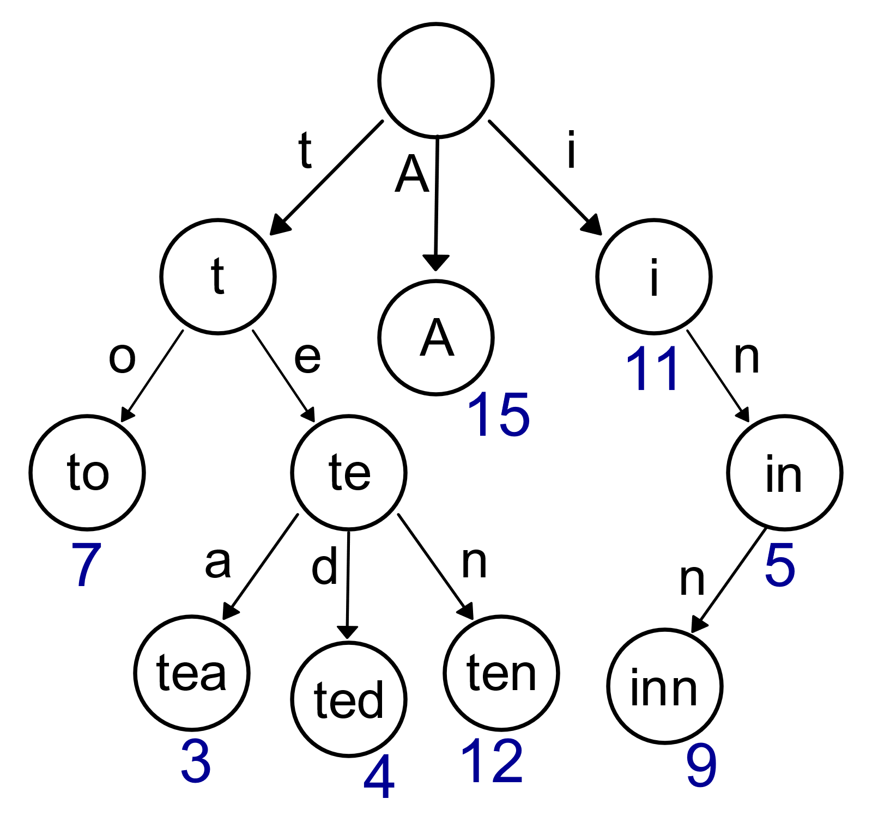

Figure 1 public domain <https://upload.wikimedia.org/wikipedia/commons/thumb/b/be/Trie_example.svg/1024px-Trie_example.svg.png>

As shown in Figure 1, an example of a Trie is shown. It is similar to a binary tree but instead of only 2 possible nodes there can be as many as wished for. Each possible node contains a single character and the path from the root to a leaf (ignoring the character in the root) evaluates to a full word.

Tries have a real life applicable usage where they are most useful in predicting words. For example, all the possible words that can be created given that the input starts with x are the nodes that descend from the current position of the node. In Figure 1given that input “te” is input there exists only 3 possibilities, an “a”, a “d” or an “n”.

Using these tries it would be possible to determine the probability of how many other words share the same starting letters as a word currently trying to determine the morphemes of. It is highly likely the peak corresponds to morpheme boundaries.

A normal equation for this calculates the probability of a letter given the current word. This is a usage of Bayes theorem where the probability is:

P (A|B) = ( P(B|A) ・P(A) ) / P(B)

Going through this with an example is the word “reports”. The morphemes for “reports” are “re”, “port” and “s”. In order to devise this the probability of (s|report) is needed to be obtained. Bayes theorem provides the answer to be the probability of “reports” divided by the probability of “report”. The probabilities will be an O(1) lookup of the forward and backwards tries.

#### 4.2.1 Forwards and Backwards Tries

Each node contains the value containing how many words start or end (depending on the type of trie it is) with the sequence of letters up to this node from the root. As an example, this means that the node for “a” that comes directly from the root node is the number for all the words in the lexicon that start with “a”.

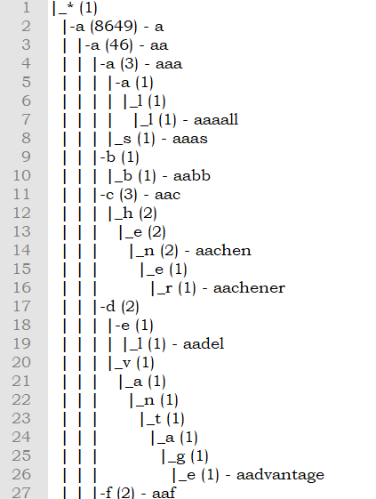

Figure 2 Example of forwards Trie

The backwards trie is a reverse kind of Trie. Instead of starting with the highest node being the first letter, the highest node is instead the last letter of the word. This means that the probability of a word ending in x can be compared to calculate the transitional probability. An example of a backwards Trie would

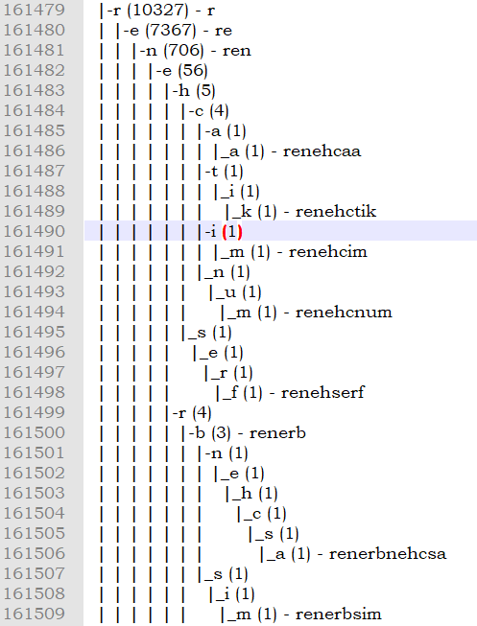

Figure 3 Backwards Trie example

All the words are in reversed order. For example, “renehserf” is “freshener”. This means that the probability of the end of a word can be calculated.

#### 4.2.2 Adding to tries

This algorithm starts at the root node and takes in a word and loops over the characters in it. For each character it checks whether that character exists within the descendants of the current node.

If it does it just increments the count of the node and sets the child node containing the character to the next node for the next loop.

If it does not find a descendant node with the character currently being looped over then it will create that node for the character with an initialised value of 1.

#### 4.2.3 Get the Trie node’s value (find_prefix)

To get the value contained at each node (the amount of words that are descended from that node) a traversal algorithm is needed. This is the crux probability function mentioned in the Pitler & Samarth method.

This algorithm loops through the children nodes to find the next character then replaces the current node with the new node if found and a 0 with a flag if it hasn’t been found. The algorithm does not need to maintain the path in memory as it is only looking for the final node that contains the number of all words that descend from it.

##### Tests for Trie

###### Adding to the Structure

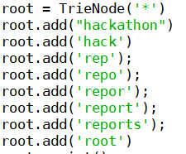

With this code the structure contains the root node along with a sample of other words chains. Printing this out with the function



Results in the following:

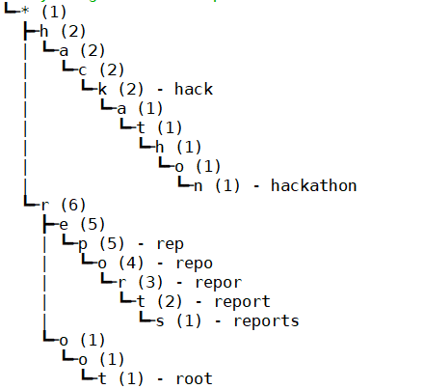

###### Finding

Finding has 3 results applicable.

1. A word is found, and the value returned
2. The prefix is found, and the value returned
3. The prefix doesn’t exist

Results 1 and 2 are practically the same, the only difference is the algorithm has not found an actual word that was in the wordlist and instead has found a fragment of other words.

Result 3 is the error condition. If this happens in the main program it will crash. There is intentionally no exception made for the finding function as these errors are helpful in determining bugs made by changes in the program. The probability function that simply divides the results got from the finding algorithm will crash if it receives a 0 as in the word doesn’t exist within the Trie structure. When the main program is running correctly this third condition should never happen.

This is the structure of the trie at this point

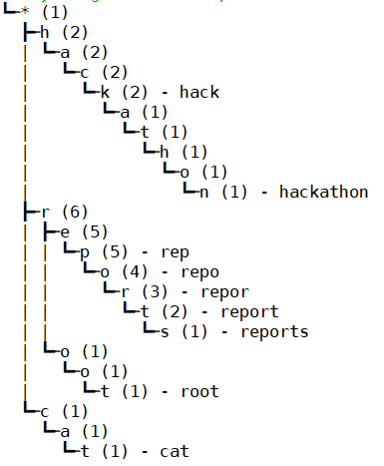

Figure 4

While these are the inputs noting all 3 error conditions.

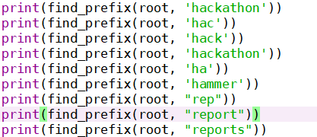

Figure 5

These are the results:

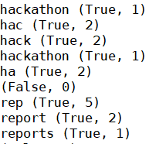

Figure 6

Once the probability function reaches the 0, as the word “hammer” doesn’t exist it will attempt to divide by 0 crashing the program. As the program works symmetrically it doesn’t matter if a numerator is 0 because at some point the same string will be passed to the denominator and the proceeding attempt to divide by 0 will crash the program.

For the rest of the inputs, as can be seen from Figure 4 they match up perfectly with the trie structure.

### 4.3 Inputs and Outputs

#### 4.3.1 Inputs

The inputs are configured by the command line arguments. The input file by -i, the output file by -o and the gold standard by -g. The wordlist uptakes the words per line. If the frequency is available it stores that too, if the frequency is not present and there are only words per line it’ll just set the frequency to 0. If the frequency is a factor, for example experimentation on which empirical numbers work best then the program can opt to ignore any words that have lower than a specific value.

The input receiver does use a trick, as it ascertains whether the frequency exists in the wordlist through the use of a space check it can work with both files containing just words or “frequency word”. This does mean it requires either one of two specific formats.

The gold standard is just used to compare with the output file. The program goes through all gold standard words, removes the segmentation marker and checks to see if the word is in the output. If it is, it starts evaluating the two words. If not, it goes to the next one.

#### 4.3.2 Outputs

The program then outputs the standard to be compared against the gold standard. The format matches the gold standard format in that each line contains a word separated by the segmentation marker.

It does this to prepare for evaluation and remain modular so that the evaluation code can be picked up and placed in another file and run on a file with the required format.

### 4.4 Scoring affixes

In order to devise these programmatically it is necessary to go through each word in the wordlist.

The function does a brute force method by going through each potential split in the word to split it into 2 parts to test whether the three conditions outlined in Pitler & Samarth’s method are true.

For prefixes it works with the backwards trie and tests second part of the word to score the first part while with suffixes the forward trie is used to test the first part of the word to score the second.

For example: the word “reports” has the suffix of “s”. Thus, the forward trie will be used as outlined previously to check the probabilities. It will iterate across the entire word from start to finish splitting up each point so that each consecutive part of the word has an opportunity to be tested. The function call looks like this:

|  |  |
| --- | --- |
| First word part | Second word part |
| r | eports |
| re | ports |
| rep | orts |
| repo | rts |
| repor | ts |
| report | s |

The first criterion addresses the observation that root words are attached by prefixes and suffixes.

The first criterion is formalised by checking that the word part being tested (for suffixes it’s the first part and vice versa) exists within the dictionary. As a aside it is important that the words are in hashable format that enables O(1) constant time lookup otherwise each word part will run a O(n) operation putting the morpheme analysis at a O(n2) runtime.

To implement this, two variables have been used, one to hash the words and another to iterate through in dictionary order.

The second and third condition check the root has more than one potential children implying that other affixes may be attached to the root but that the root’s parent node only has a single node identifying it as a true root.

They are formalised by checking the probability of the tested part of the word that has the last letter cut off is divided by the probability of the tested part of the word is near 1.

Finally, the third condition checks the tested part’s probability divided by tested part with an additional appended letter is less than 1.

Each word part that is put through the function that scores potential morphemes is added to a wordscore dictionary. This keeps track of how many times

The other part of the word is tracked in a potential morpheme dictionary. If all three conditions are passed. The word part has its score raised by 19. If it fails any test it’s score is lowered by 1. This is an arbitrary value to punish words that are deemed not probable enough to be **the** morpheme for that particular word. The conditions operate on a 5% acceptance rate in that they need to pass the tests at least 5% of the time in order to be considered to be a morpheme. Words can contain the same parts and are judged many times. For example, the word “mountains” and “rivers” both would at some point test “mountain” & “s” and “river” & “s” thus rendering judgement onto both “mountain” and “river” but “s” twice. Extend this idea across all words and the word part “s” will be judged very frequently to ensure it’s a morpheme.

This means word fragments such as “en” are heavily punished for being in words like “heaven” or “kindergarten” or similar words.

Being the most likely morpheme for that word is also important. There might be a high probability of a “d” being the suffix in words like “rooted”, “baked”, or “loved” but the actual morpheme here is “ed”. The conditions prevent affixes like “d” from rising to the top together with “ed” while they reward morphemes like “~s” since these are far more likely to appear together than the fragment “d” by itself.

The same idea applies the prefixes but instead using the backwards trie the conditions. For the first condition the second part is checked whether it exists within the dictionary. The second condition checks the probability of the reverse of the second part divided by the probability of the reverse of the second part with the last letter removed. Finally, the third condition checks the probability of the reverse of the second word part divided by the probability of the second word part with an added letter.

#### 4.4.1 Pruning

Pruning performs the task of checking if morphemes consist of two other morphemes. If the two smaller morphemes have a greater score than the first bigger morpheme then the bigger morpheme is removed. The program does this by looping through the morpheme in the word score, iterating across the words to see whether they exist within the word score. If both the first part and second part are in the word score, they are then tested against the original morpheme and removed if both the first part and the second part of the morpheme have a higher score than the original morpheme.

Prefixes and suffixes are separated for the pruning as morphemes in prefixes do not consist of morphemes in suffixes an vice versa.

All entries in the word scoring dictionary with a negative score are removed from consideration at the end of the scoring sequence.

|  |  |
| --- | --- |
| Word fragment | Score |
| “re” | 1800 |
| “s” | 2000 |
| “en” | -500 |
| “un” | 800 |

All but “en” remain in in the wordlist.

##### Tests for scoring and pruning:

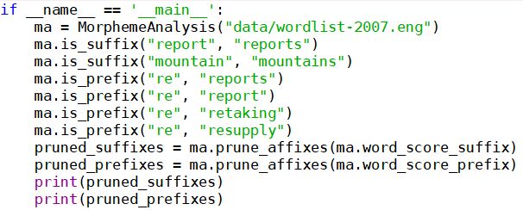

Figure 7

Testing this on the words for: “reports”, “report”, “mountains”, “retaking”, and “resupply”.

“Report” and “reports” correctly segments the “s” from the end of “reports” as it does from mountains too. However, the scorer only picks up the “re” from resupply and not retaking or report suggesting its sensitivity is not as strong as it could be. According to the gold standard from pyports, the word “report” doesn’t actually segment the “re” in “report” but the word “retaking” should trigger a segmentation showing that the algorithm or at least this implementation is not perfect.



Figure 8

As can be seen from Figure 8 the score for “s” is +19 for both “reports” and “mountain” while the prefix for “re” has been both rewarded and punished. It’s been rewarded for “resupply” but punished for “reports, “report” and “retaking” adding 19 but subtracting 1 three times.

Pruning is necessary here because the dictionaries containing the prefixes and suffixes are initialised with every word in the wordlist so navigating to the words that are not 0 would be troublesome as there’s nearly 400,000 for this wordlist.

### 4.5 Segmenting affixes

Segmentation of affixes works with the same concept of transitional probabilities but with peeling off affixes from the root leaving the root itself untouched. It works with the pruned morpheme list to only keep morphemes that have been rewarded 5% of the time more than punished. The segmenter will go through the word again and get all possible combinations of word parts.

Then with those potential prefixes and suffixes the probability of the part of the word specific to the prefix or suffix is tested and the combinations of the 1st and 2nd part of the words are scored. Whichever is less than 1 and is the lowest is the deciding segmentation. If the transitional probability segmentations are not less than 1 then the word is left as is.

For example, for suffixes the forward trie is used to get the probability of the prefix word part divided by the probability of the prefix word with the first letter of the suffix word added on.

For prefixes, the backwards trie is used to get the probability of the reverse of the last letter of the prefix word appended to the suffix word divided by the probability of the suffix word.

Unfortunately, the prefix segmentor is too sensitive and picking up a lot more errors than picking up correct segmentations. Due to this, disabling the prefix segmentor increases the precision and f-score of the program. However, from observing the affected prefixes it’s been possible to optimise it by removing word parts that are of length one. Even so the scoring is worse with the prefix segmentation working by about 4% (63% 🡪 67%) with that optimisation (otherwise it would be roughly 51%).

##### Tests:

Figure 9

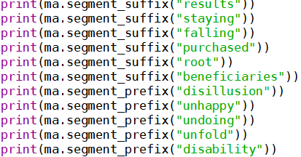

Figure 10

As can be seen from Figure 9 and Figure 10 the results from testing these words. For the “re” it works well as well as all of the endings. However, there is too much sensitivity for the prefixes as it’s picking up “fal” and “di” instead of “fall” and “dis”. As the “dis” has the same probability as “di” a consistent but random one gets chosen depending on the ordering of the word fragments. Attempts to solve such as allowing the longer word first this would render the solution language specific. Similarly, with pruning this would be avoided if the prefixes and suffixes would be tested together. However, in this case the “s” from “dis” is not the same as one denotes plurality. “s” is not a prefix which is why it is not pruned from the prefixes.

### 4.5.1 Multiple affix peeling ❌

There are a few words in the English language that can consist of multiple prefixes or suffixes. For example, “unrequited” can be split into the morphemes “un”, “re”, “quit”, and “ed”. However, these kinds of words are used less frequent in English.

One method that might

### 4.6 Evaluation

The method of evaluation iterates through the gold standard list of words, checks if the word is in the outputted proposed word segmentations which will be called “word standard” for brevity. The gold standard word’s morphemes are compared with the word standards.

True positives are recorded where there is a correctly placed segmentation marker between morphemes in both the gold standard and the word standard. For example, if the gold standard reads *“cup bearer”* and the word standard also reads *“cup bearer”*.

False positives are recorded for situations where the segmentation marker is placed incorrectly in the word standard.

False negatives are recorded for situations where the segmentation marker has been placed in the gold standard but not within the word standard.

These three values are used to calculate the precision, and recall. The precision is calculated by dividing the true positives by the true positives + the false positives. The recall calculated by dividing the true positives by the true positives + false negatives. Finally, the f-score is calculated by calculating the harmonic mean between the precision and the recall.

##### Tests:



Figure 11

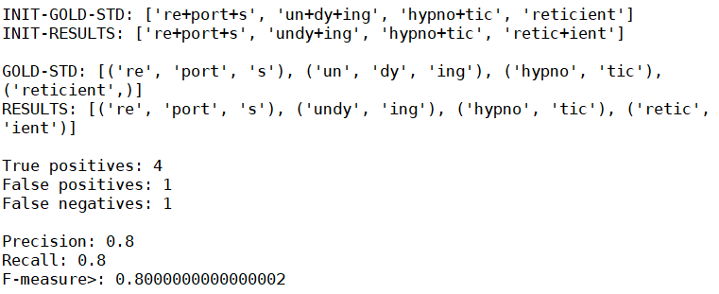

Figure 12

As can be seen from Figure 11 and Figure 12 the evaluation tests the segmentation marker’s position to test if they’re in the right position. As 4 markers are in the correct position (“re**+**port**+**s”, “**+**ing”, “**+**tic”) they are awarded 4 true positive results. However, there is one in the incorrect position in “retic**+**ient” and a position where a market should have been but wasn’t (“un+”).

## Chapter 5 – Experiment Results

These experiments were designed in mind to discover tweaks or quirks to increase the f-score or to discover interesting quirks that might allow the discovery of what is causing the issues of programmatic morpheme segmentation that is difficult to solve.

As with all tests the control must be defined. This is known as the baseline score. Results have been truncated to 5 significant figures.

|  |  |  |
| --- | --- | --- |
| Precision | Recall | F-Score |
| 0.52657 | 0.71711 | 0.66871 |

### 5.1 Removing Punctuation from wordlist

|  |  |  |
| --- | --- | --- |
| Precision | Recall | F-Score |
| 0.52657 | 0.71711 | 0.66871 |

As this result is the same score as the baseline it can be surmised that the program was unable to deal with the punctuation regardless and the same pitfalls it fell into the without punctuation it fell into this time too.

### 5.2 Threshold Modification

|  |  |  |  |
| --- | --- | --- | --- |
| Threshold | Precision | Recall | F-Score |
| 0.01 | 0.52195 | 0.71333 | 0.66460 |
| 0.003 | 0.52913 | 0.71711 | 0.66953 |
| 0.002 | 0.52913 | 0.71711 | 0.66953 |
| 0.001 | 0.52913 | 0.71711 | 0.66953 |
| 0 | 1.0 | 0.00658 | 0.00821 |

When the threshold is 0 the recall obtains practically nothing showing that most of the words do not fit neatly within the equation which is why Pitler & Keshava have determined the threshold to be necessary. Increasing the threshold reduces the score while having it at the same magnitude type values (0.00x) doesn’t change it at all until later values.

### 5.3 Removing the first condition (word existence check)

|  |  |  |
| --- | --- | --- |
| Precision | Recall | F-Score |
| 0.28219 | 0.68667 | 0.53368 |

Without the first condition checking the currently testing word is in the dictionary the precision drops heavily dropping the F-score. This is most likely because the number of false positives the evaluator picks up is increased since there are a higher number of morphemes that haven’t been pruned. The segmentor function is adding segmentations where they shouldn’t exist.

### 5.4 Arbitrary Scoring

|  |  |  |  |
| --- | --- | --- | --- |
| Reward | Precision | Recall | F-Score |
| 21 | 0.52427 | 0.71053 | 0.66339 |
| 20 | 0.52683 | 0.72 | 0.67081 |
| 19 | 0.52657 | 0.71711 | 0.66871 |
| 18 | 0.53171 | 0.71711 | 0.67036 |
| 17 | 0.555 | 0.73026 | 0.68688 |
| 16 | 0. 555 | 0.73026 | 0.68688 |
| **15** | **0.56633** | **0.73026** | **0.69030** |
| 14 | 0.56771 | 0.71711 | 0.68125 |
| 13 | 0.58333 | 0.69079 | 0.66624 |
| 12 | 0.58427 | 0.68421 | 0.66158 |
| 11 | 0.58523 | 0.67763 | 0.65689 |

### 5.5 Wordlist Testing

|  |  |  |  |
| --- | --- | --- | --- |
| Year | Precision | Recall | F-Score |
| 2010* | 0.5 | 0.6688311688311688 | 0.6265206812652068 |
| 2009 | 0.5242718446601942 | 0.72 | 0.6699751861042185 |
| 2008 | 0.5265700483091788 | 0.7171052631578947 | 0.6687116564417178 |
| 2007 | 0.52657 | 0.71711 | 0.66871 |
| 2005 | 0.518324607329843 | 0.7226277372262774 | 0.6698240866035182 |
| Pyports en_conll2000_train | 0.6875 | 0.6470588235294118 | 0.6547619047619049 |

*2010 requires the format to be in latin-1. This variable is at the start of morpheme_analysis.py

2005 till 2009 are relatively stable. 2005 has 1 MB of words while 2007-2009 have 4 MB. However, 2010’s wordlist shoots up to 11 MB suggesting that a lot of junk data not suitable for morpheme segmentation was provided. This lowered the performance of the segmentor.

### 5.6 Frequency Check

|  |  |  |  |
| --- | --- | --- | --- |
| Frequency | Precision | Recall | F-Score |
| 1 | 0.639751552795031; | 0.6477987421383647 | 0.6461731493099121 |
| 2 | 0.5692307692307692 | 0.7115384615384616 | 0.6776556776556776 |
| 3 | 0.5309278350515464 | 0.6645161290322581 | 0.6326781326781327 |
| 5 | 0.5026178010471204 | 0.6193548387096774 | 0.5918618988902589 |
| 10 | 0.5223880597014925 | 0.6818181818181818 | 0.642594859241126 |
| 15 | 0.5314009661835749 | 0.7236842105263158 | 0.6748466257668712 |
| 20 | 0.5242718446601942 | 0.72 | 0.6699751861042185 |
| 25 | 0.5320197044334976 | 0.7105263157894737 | 0.6658446362515413 |
| 50 | 0.5422885572139303 | 0.7266666666666667 | 0.6803995006242197 |

Increasing the frequency required to add a word to be tested and segmented doesn’t help as much as one might assume. As the number goes up the sample sizes goes down which explains the fluctuating past 5-10. It seems that requiring 2 is the magic number to reduce junk data’s influence in this dataset.

### 5.7 ❌Words ending in E

## Chapter 6 – Conclusion and Future Thoughts ❌

## Chapter 2 – Experimentation and analysis

As this project will be written in python the Natural Language Toolkit (NLTK) might be useful for working with language data. The usage of stemming, tokenisation and semantic reasoning available via the NLTK would make some of the methods far quicker to implement worth explaining this a bit more.

# References

A.Hafer, M., & F.Weiss, S. (1974). Word segmentation by letter successor varieties. *Information Storage and Retrieval*, 371-385.

Ager, S. (n.d.). *Yoruba language*. Retrieved from Omniglot: https://www.omniglot.com/writing/yoruba.htm

Baroni, M., Matiasek, J., & Trost, H. (2002). Unsupervised discovery of morphologically related words based on orthographic and semantic similarity. *Morphological and Phonological Learning - Association for Computational Linguistics*, 48-57.

Beaver, I. (n.d.). *Python Package Index*. Retrieved from https://pypi.org/project/pycontractions/

Bengio, Y., Schwenk, H., Senécal, J.-S., Morin, F., & Gauvain, J.-L. (2006). A Neural Probabilistic Language Model. Studies in Fuzziness and Soft Computing. 137-186.

Bird, S. E. (2009). *Natural Language Processing with Python.* O'Reilly Media Inc.

Booyabazooka. (2006, July 15).

Bordag, S. (2005). Unsupervised Knowledge-Free Morpheme Boundary Detection.

Creutz, M., & Lagus, K. (2007). Unsupervised Models for Morpheme Segmentation and Morphology Learning. *ACM Transactions on Speech and Language Processing*.

Creutz, M., Stig-Arne Grönroos, Oskar Kohonen, Mikko Kurimo, Krista Lagus, Peter Smit, & Sami Virpioja. (2015, July 14). *Morpho Project*. Retrieved from Morpho Project: http://morpho.aalto.fi/projects/morpho/index.html

Goldsmith, J. (2001). *Unsupervised Learning of the Morphology of a Natural Language.* Chicago: Computational Linguistics archive.

Gonzalo, N. (2001). A guided tour to approximate string matching. *ACM Computing Surveys*, 31-88.

Kilic, O., & Bozsahin, C. (2012). Semi-supervised morpheme segmentation without morphological analysis. *LREC 2012.* Istanbul: LREC.

Levenshtein, V. I. (1966). *Binary codes capable of correcting deletions, insertions, and reversals.* Soviet Physics Doklady.

Lignos, C., & Beck, J. (2011). The$Power$of$Objects$in$Morphology$. *LSA Annual Meeting.* Pennsylvania: University of Pennsylvania.

Mathias Creutz, Stig-Arne Grönroos, Oskar Kohonen, Mikko Kurimo, Krista Lagus, Peter Smit, & Sami Virpioja. (2010). *Morpho project*. Retrieved from The Morpho Challenge: http://morpho.aalto.fi/projects/morpho/

Edward Sapir (1884–1939).  Language: An Introduction to the Study of Speech.  1921.